pSTaRT

Manual and Description

Kurt Höblinger

5.3.2021

# Description

pSTaRT is an Application for the Apple iOS operating system. It is optimized for iPhones and iPads. The goal of the application is to facilitate triaging using the mSTaRT scheme and keeping track of the triaged persons.

The application is available in English and German.

# Manual

## Create a new person

Creating a new person results in the appearance of the mSTaRT questionnaire. To trigger its appearance a PLS-Number can be entered manually or by scanning a PLS-Pouch barcode. The barcode must comply to the Code39 definition (<https://de.wikipedia.org/wiki/Code_39>). Austrian PLS-Pouche barcodes do comply to this definition.

There is no check on the PLS-Number syntax. That means that “4 AS 2401” is just as valid as “injured guy”. An empty identification is not valid. Duplicate identifications require an explicit confirmation by the user.

The mSTaRT works just as it would work in its paper variant. As soon as a conclusion regarding the correct triage group is reached, the questionnaire ends. However, the user has the option to not just accept the result of the questionnaire but also to change the decision manually.

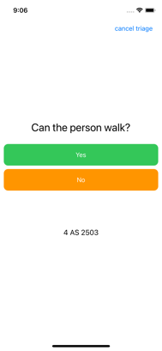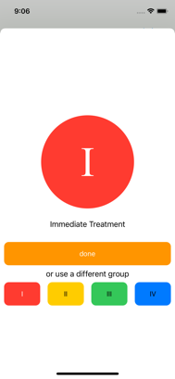

Once a triage group was chosen, the questionnaire closes, and the user returns to the landing page allowing the user to assess another person immediately.

## Person List

### Editing

The persons list contains all persons from the current incident (car crash, earthquake, avalanche…). The user must manually delete the complete list (trash bin icon) if another incident starts.

Individual persons can be deleted by swiping the entry to the left and pressing the now appearing delete button. Alternatively, an edit mode can be toggled on and off by pressing the pencil icon.

Choosing another triage group is also possible. The user must select a person by tapping on the entry. A separate view shows the person’s details and a selection of triage groups similar to the initial presentation at the end of the questionnaire.

### Export

For further analysis the list can be exported at any time by tapping on the export button in the person list view. The resulting CSV file can then be e-mailed, stored in the files application or transferred to any other app accepting CSV files.

# Contact

This app is developed by Gregor Kurt Höblinger. The developer can be contacted via e-Mail ([office@nitricware.com](mailto:office@nitricware.com)).